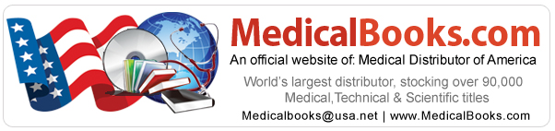

Drug

Endocrine Drugs Books

Endocrine drugs correct the overproduction or underproduction of the body's natural hormones. For example, insulin is a hormone used to treat diabetes. The female sex hormones estrogen and progesterone are used in birth control pills. To relieve uncomfortable symptoms of menopause, including sweating, hot flashes, and mood swings, as well as to delay some long-term consequences of menopause, including osteoporosis and atherosclerosis, physicians often prescribe the synthetic hormones estrogen, progestin (a synthetic form of progesterone), and sometimes androgens. This therapeutic approach is called hormone replacement therapy (HRT). However, recent studies indicate that HRT may be associated with an increased risk of breast cancer, heart attacks, strokes, and blood clots, and it is unclear if the benefits of HRT outweigh these risks. Each woman and her health-care provider should assess her need for menopausal symptom control and her potential risks and benefits before starting HRT.

